1/30/2023 - 21/04/2023

Agne Postnikova (Student)

Software project- Joachim Pietsch, Sue Reardon

Software Project Report

Agne Postnikova

# Table of Contents

# Introduction

# 2.0 Business Concept

# 3.0 Requirements

# 4.0 Web application Design

# 5.0 Database Design

# 6.0 System Design

# 7.0 Testing

# 7.1 Functional Testing

# 7.2 User Testing

# 8.0 Project Management

# 9.0 Reflection

# References

## **Section 1 – Introduction**

Coming up with ideas was a struggle for me. After a while I came up with three; Mental health service, Memory safehold, and Jewellery shop Service. My first idea was inspired by the applied psychology elective I did in January, I really loved that subject and I knew I wanted to do something with it. A mental health service was the basic idea I had but I wasn’t sure how I would expand that idea and make it more than just a service where people can search for therapists available to them. Sure therapists themselves could register and offer, but that wasn’t enough for me. I moved on and thought of this other service that would provide people with a safe space to upload their images and make a little online album. Individuals could create group chats and everyone can upload their shared trip or something along those lines. Another little thing would be notes they could add with images and it would be personalised to each group/individual however they’d like. There are paths to expand the idea of that one but I still wasn’t convinced with myself. Then I thought of my final idea, this was a business one unlike the first 2. At first I thought of this jewellery exchange website where people can buy and sell jewellery- but that sounds like they can talk and just exchange them, not upload and sell, browse and buy. So, I changed it to this niche jewellery mini shop that each user has full control over. It will function like any other online shop from the buyer perspective, then people can register/upgrade to sell on there too. Its basically depop but specifically for jewellery. I am more comfortable with this one even though I still haven’t fully thought it out. I put up all these ideas in miro.

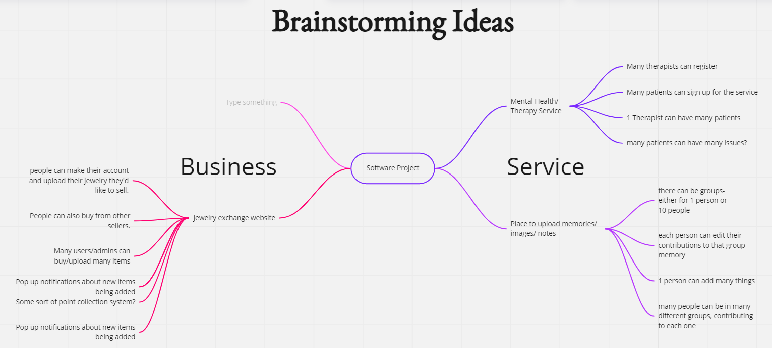

Figure Miro brainstorm for ideas

After I was set with my jewellery website idea, I completed the feasibility worksheet and section two of the report. Then I really started realising how much I still haven’t thought through. From the business point of view to the supplier. I had no idea what I was doing to be honest but I learn as I go so I’m sticking with it and I know I’ll figure it out along the way.

During the time I was filling out section two of the report I was searching up the official terms of some of the sections, like “business model” and “market research”. I vaguely knew what they meant but I had to look it up to be 100% sure, and even then I still am not sure I did it correctly. I looked up websites that are similar to the idea I had and it didn’t take me long to realise that the services that already exist, are very long winded and complicated. In order to be able to just put something online for others to view, you have to get in contact with their team, send images of the jewellery, they analyse it and then you negotiate the price with them. Only after all of that, can others have the opportunity to view your piece. I instantly knew that I wanted to make life easier for people who want to simply sell their pieces without any headaches. Of course there’s the part where “how can we trust if it is real gold and/or diamonds?” “is that a fair price for that?” in this case we just have to trust that the seller is being honest and is trustworthy.

I put up the schedule for this project up on my miro board too so I can easily access it and keep track of each task that I’ve completed. I’m adding a green tick to every week that has passed.

Figure Screenshot of completed week (green tick)

On Friday we could start setting up our Laravel projects. I’m going to be completely honest here- I still struggle with the whole setting up part. I asked some of my classmates for help but something still didn’t go right, when I try to run serve, it doesn’t work. I only now realise that I had technical problems in my Laravel class with Anne, and we had to make a separate “Lara2” folder for that project- but I’m not sure if that has any connection with my current problems. I looked through Anne’s set-up lectures and it looks like I’ve done everything but it doesn’t work, so of course I missed something somewhere. My next steps are to look through Anne’s notes again and/or the Laravel booklet on the teams channel.

Well I did some research (stack overflow) on why I can’t run artisan. I had opened the folder that contains the project- so I had to cd to my actual project (not the folder its sitting in). Now everything works and I can see the Laravel documentation page.

I just realised there’s some sort of mistake which I’m not sure how to fix. The folders are a mess and I don’t want to move on in case it causes more problems or I have to start again. In my Laravel folder there’s all the projects I’ve made. I have a folder named SoftwareProject, that contains another folder called swproject23-AgnePK, within that is the contents of our github class repository contents and in there is also another folder called SoftwareProject. I don’t think its supposed to be like that so ill double check with a lecturer or Craig.

## **Section 2 – Business Concept**

Since my business idea is very much like a service, its tough coming up with ways to make money from it. How will I pay my development team? How will I make money from the website? Who will pay for shipment for the premium version? How much will the premium version cost? That’s not even half of the questions I ask myself.

Like any other online shops there’s ads. I’ll let my customers pay for their own ads on this site. Alongside the ads, there will be a premium version which will let the user have free shipping when buying and selling. Premium will also let the user have a different colour username to show they’re premium, I’ll think of other things to add throughout the project.

Jewellery is hugely popular. There aren’t many people who don’t wear some sort of jewellery or other. Since covid any online shopping has increased, along with it the jewellery market.

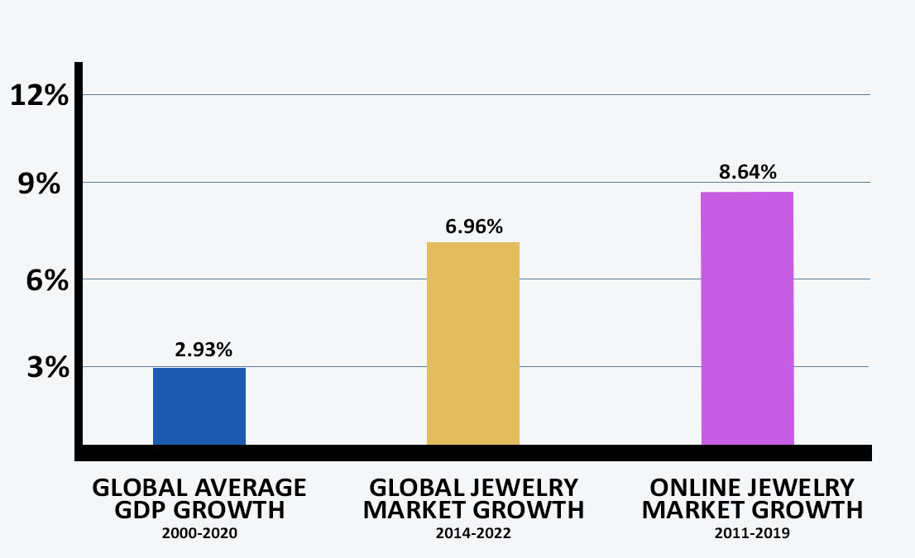

Figure Market growth rate for Jewellery- <https://classywomencollection.com/blogs/fashion-guide/jewelry-market>

Figure Most popular searches for Jewellery- https://www.finder.com/uk/jewellery-statistics

Figure 4 is very interesting because of how the data is visually represented. The size of the text represents the popularity. “Silver earrings” are the most popular while “gold cuff bracelets” aren’t as popular. It’s incredibly easy to understand. If you visit the website you can hover over each one and it’ll tell you the statistics!

The next step is my team to develop this business project. Trying to figure out who I will need to hire with no previous knowledge is quite challenging. Of course there’s all the obvious like web designers and developers, then there’s the project managers for each section and stage of developing one. Ill need to pay some people to test out the application to find out where to improve. Its not as simple as just developing a design you just made. I found a website that clearly explains all the ins and outs of web development team roles. <https://getflywheel.com/layout/web-development-team-roles/> is a great website to get a greater knowledge of the business world and how it all works.

## Section 3 – Requirements

Laying out all the little functions my website will be able to carry out took longer than expected, and once I thought I was done, I remembered another thing so my brainstorm kept getting bigger and bigger. I do everything on Miro first then modify it when I document on the report.

Figure Miro: Website requirements brainstorm

Figure 5 is my current work on each page that I’m planning to develop. So far there will be seven pages and this displays what each page will hold. Of course this isn’t final, I’m still remembering little things that I have to add so I will be making more changes to it but this is where I’m currently at. I’m making sure that everything I put down is realistic for me to be able to recreate in code.

I know there has to be something different about my website idea, something unique but that’s kind of hard to come up with. I’m not the most creative person in the world, my idea for this project is pretty basic but I think it’s important to be able to keep it realistic and not get any unrealistic hopeful ideas for it. I can always expand on my idea and develop it further.

In the report I also worked on researching two similar websites to mine. Those are [Depop](https://www.depop.com/) and [Etsy](https://www.etsy.com/ie/). They both have overlapping functionality to mine, people can register with them, buy goods from other people and also sell their own things. Those are the main functions.

Depop is the lesser quality website compared to Etsy. To most users, the website doesn’t look good. It’s very plain and basic, it almost looks clunky and blocky which is not pleasing to the eye. I have heard people around me talk about Depop, it was mainly negative comments. There are a lot of talks about fraud around Depop too. Of course, on the Depop website they state that they keep their users safe and everything they have to say to stay alive, but that isn’t doing enough. Read <https://oneshop.com/blog/depop-scams> to find our more on what users are warned about before joining Depop. Slightly concerning, is it not?

Etsy on the other hand is much more professional. The build of the website is really put together, and most users come out happy. Of course there is fraud everywhere but Etsy takes more care of their starting entrepreneurs. They have this help link <https://help.etsy.com/hc/en-us/articles/360000343128-Suspicious-Messages?segment=selling> for any users receiving odd messages that could be scammers or fraud. A lot of my friends and myself included, have bought from Etsy and it is always a pleasant experience. Etsy isn’t a direct comparison to my business idea. Anyone who wants to start a business of their own, make items to sell (e.g., art, jewellery (mainly customised), clothing, wedding gifts, literally anything). Etsy is the go to place to start up. A few things remain the same, though. People can sell their goods, and buy goods, which is the main functionality.

Getting feedback from real life people was the next step. I conducted a survey (Microsoft forms) and sent the link to my classmates and some friends. Receiving a few surveys myself too, I realised how so many of them I couldn’t answer because it was only for people who would use that service. I made sure that anyone could answer my one. Everyone were the targets, not just online jewellery shoppers. The results showed a few things. First is that online shopping for jewellery is so common, not just buying but also receiving online bought jewellery. One participant brought to my attention something that would make user experience much better, sorting item by how the user wants to shop. That also improves the heuristic evaluation. This is why it’s so important to get people outside the project to get valuable insight like this. It’s so easy to forget about little things like that, that can make so much difference. Figure 6 is a screenshot of the response I mentioned (number 3).

Figure screenshot of response

Requirements are important to establish early on. They can also help bring to light any goals that may be unrealistic or something that is less important that can wait. Working on this section was very insightful, this is because I realised how big my ideas were, a bit too big. There’s so much functionality that would be good to have that is possible to do, just not in the time space I have to work on and finish this project. I know now, I have to set realistic expectations.

Listing and briefly explaining the basic functionality of the important must-haves and the lesser important is vital to lay out everything and get a clear view of what one needs to work on and other things that one can add if there’s more time left. Even still, with more realistic expectations set, there’s a lot of things to work on.

## Section 4 – Website Design

Designing a website within one week is a challenge, but I already knew what this website will be like so that makes it that little bit easier. The challenge was in the wireframes, not knowing what’s too much detail, what’s not. In class when I was talking to some of my classmates, theirs was less detailed, so comparing that to mine, mine is a bit much. Though the important thing is that it won’t go to waste. The extra bit of time I spent working on the wireframes will ease my mind when I start developing the website and making it look the way I want it to, ill just look back on the wireframes and it will make the process go smoother.

The first thing was the layout of the website. Bootstrap and SASS are going to be the main applications used to design the site. I am quite excited to develop a functioning website and designing it too. Combining all the skills we learnt within the last year and a half. Something I’d like to try out, but its one of those things that wont be critical for the functionality of the website, is using ChatGTP to either generate some items (which might be slightly complicated) or generate reviews for the items. It’s definitely possible but not sure how realistic it will be for this level of code.

Choosing the font and colour pallet for the website is quite challenging. First of all being slightly picky doesn’t help, but also knowing that its so important for the aesthetic of the entire website. Of course its possible to change it and it can be very easy if its organised in the correct way, but still, it would be better to make a right choice at the start. There’s two looks that I was debating between. A pastel pink-y light grey theme, or something peach-y blue-y/green , maybe tan colour but something that’s easy on the eyes and brings all the elements together. Something about the pink option makes it a but basic and very… girly, I guess (no offence). The latter option is much more neutral, its not going to push away people who prefer blue over pink or visa versa. Anyone can shop here.

The font is a very tricky one. Certain fonts make websites look certain ways, certain aesthetics. A very bold and blocky font will absolutely be the wrong choice here, that’s not the direction this is going to go in. The font pairing I chose is Playfair Display & Alice. They are a very nice pair, since the design of this website is going to be simplistic, the font can be a little serif-y.

There is one problem that may arise in the future with the font. Alice is only one style. There’s only one weight 400 and that’s it. Since it’s the body font, ill only really need to make it bigger or smaller, and different shades of grey. There are ways to work around it of course.